Brad Anderson|ESM 244 Winter 2018|February 2, 2018

Assignment 1: Blues Guitar Styles and Santa Barbara Tacos

**Part 3:**

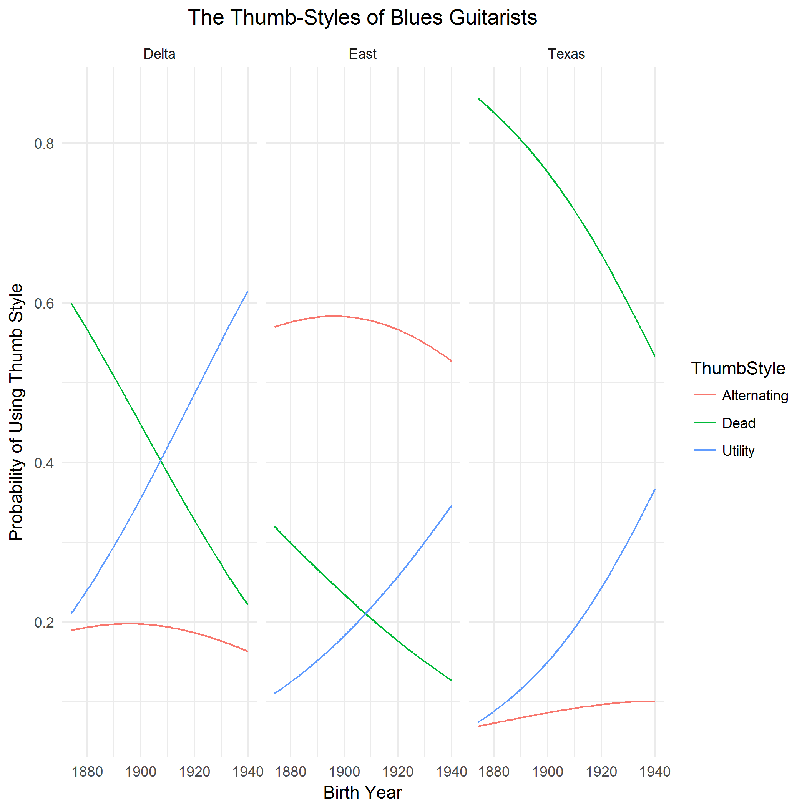

**Figure 1. Relationship between region and birth year on the likelihood that a blues guitarist will use the alternative-, utility-, or dead-thumb style.** The rise in popularity of the utility-thumb style coincides with a drop in use of the dead-thumb style. Data: A.M. Cohen (1996). The Hands of Blues Guitarists. American Music 14 (4): 455 – 479.

In general, the likelihood of a guitarist using the dead-thumb style decreased over time in all three regions. Specifically, if their birth year is increased by 1, the relative risk of using a Dead thumb style versus using the alternating or utility styles are both reduced. Also of note is the nearly unanimous use of the dead-thumb style in Texas. The relative risk (or odds) of using a Dead thumb style as you switch from the Delta region to Texas is multiplied by 3.89 , thus there is a greater probability of using the dead-thumb style if the guitarist is from Texas versus the Delta.

**Part 4:**

Vector creation:

agaves_v<-rep(1:5, c(30,22,30,109,326))

lilly_v<-rep(1:5, c(6,13,19,83,199))

Test:

f_test <- var.test(agaves_v, lilly_v)

tacos_mwu <- wilcox.test(agaves_v, lilly_v)

Sentence:

There is not a significant difference in median ranking for Los Agaves Tacos (n = 517) and Lily’s Tacos (n = 320), w(81768) = 0.75, alpha = 0.05.